**Supplementary Figures:**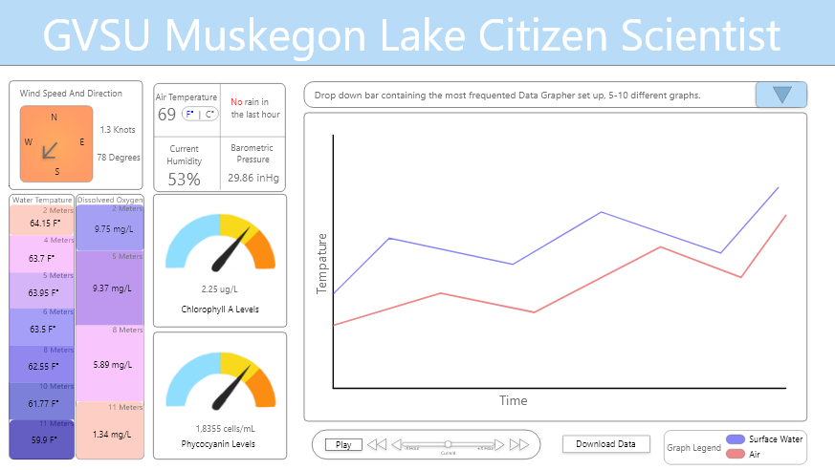

Figure : Mock-up created in Adobe Xd to showcase the Muskegon Lake buoy data that is represented on the current conditions page.

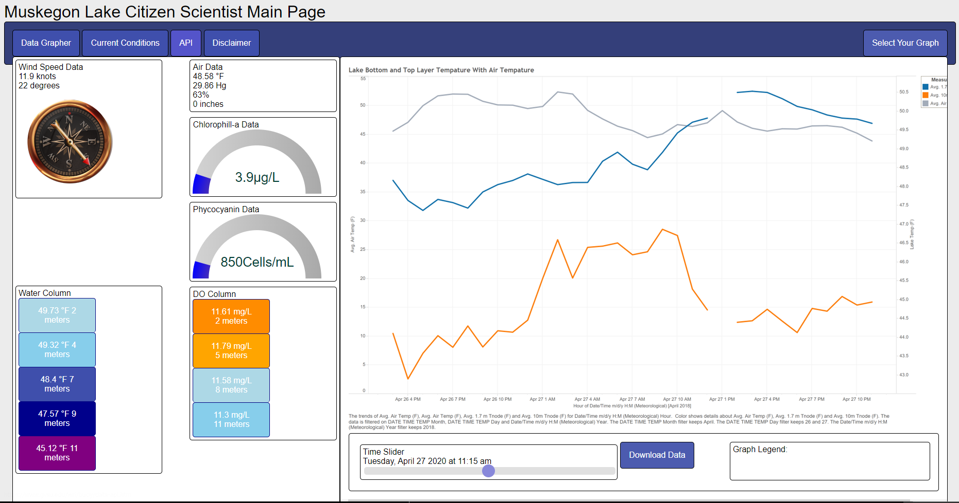

Figure : Overview of the webpage generated in Windows Visual Studio Code using JavaScript, CSS, and Html.

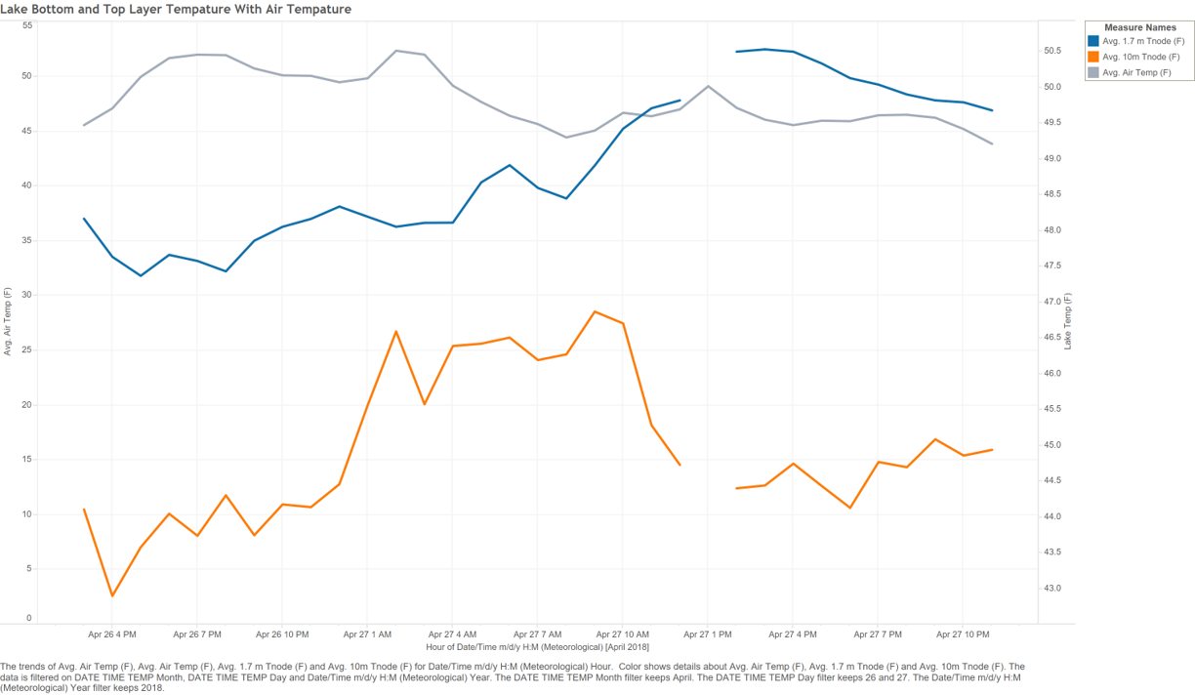

Figure : Graph showing Muskegon Lake bottom and top layer water temperature with the air temperature. Bottom temperature is at 10 meters and in orange, top temperature is at 1.7m and in dark blue, air temperature is in gray.

Figure 4: Graph showing Muskegon Lake bottom and top layer dissolved oxygen (DO) with the windspeed. Bottom DO is at 11 meters and in orange, top DO is at 2m and in dark blue, wind speed is in gray with arrows to mimic indicators of wind direction. These arrows are not indicating actual wind direction since generating a graph that does that is unknown if can be done in Tableau.

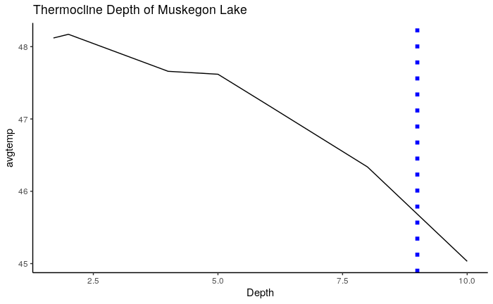

Figure 5: Thermocline depth of 9 meters in the blue dashed line for the data on April 26th to April 27th of 2018.